Errata Manual

Using ELWAVE 5.1 you will notice some differences with the previous versions.
A lot of features have been improved and also some new features have been added.

The first thing you will notice is that the menu has been changed. This document will guide you through the changes. (Note: some features are specific to certain modules and might not appear on your screen)

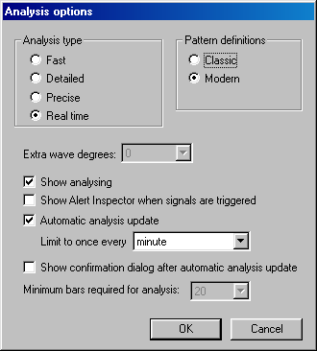
Analysis options

Under Options, Analysis you will find a new Analysis type option: Real time. This setting is recommended when you have a real-time feed open and have real-time automatic analysis updates switched on.

Price Data

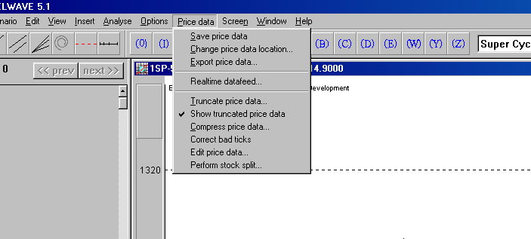
Once you have imported a chart into ELWAVE you will notice that a new item has been added to the menu bar: Price data.

Save price data: The data from the chart will be saved.

Change price data location: A copy of the original datafile will be made and this datafile can be saved under another name and/or on another location. The existing scenario will use the new datafile as reference.

Export price data: A copy of the original datafile will be made and this datafile can be saved under another name and/or on another location. The existing scenario will use the original datafile as reference.

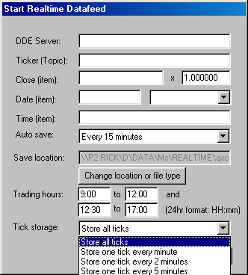
Realtime datafeed:
Some new items have been added to make the data handling smoother:
- The Trading Hours now consist of two parts. Some Exchanges have a midday break and to prevent ELWAVE from receiving false ticks during this break, you now can define two trading sessions.
- Tick Storage. If you’re historical data is in minute bars or hourly bars, but you receive real-time data tick by tick, you can now synchronise your new data with your historical data.
This feature is also very handy when you want to make your datafiles smaller.
Tip: once you have compressed the data, you cannot uncompress it. You might want to save it under another name.

Truncate price data: This feature used to be located under the Options menu. No changes to this feature.

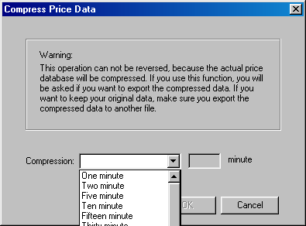
Compress price data: With this feature you can compress the data anyway you like it to be, there is also a custom option. Note: You will loose some detail because there will be less datapoints.

Correct bad ticks: This feature used to be located under the Options menu. No changes to this feature.

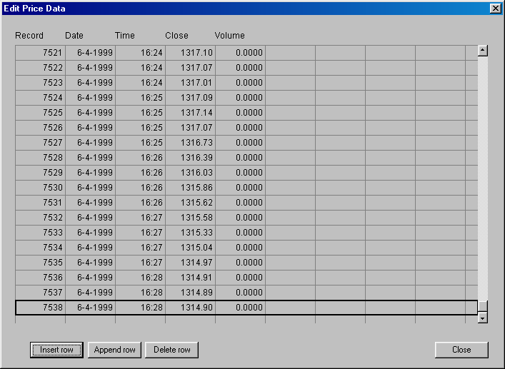
Edit price data:
This is a whole new feature in ELWAVE and is a very useful tool:
- You can insert a row anywhere in the datafile, just stand on the record where you want to insert a row and push the insert row button. ELWAVE will make a copy of that record and now by clicking on the fields you want to change, you are able to change there values. If you are missing some ticks, with this option you can manually add them in the datafile.
- Append row allows you to insert a new record behind the last. A copy of the last record will be made and you can edit their values. This option is very usefull if you want to try some what-if-scenarios. Add a record and have ELWAVE analyse the chart to see that the wave count will be and the Summary Inspector will show you.
- Delete row allows you to delete bad records or records you have created for the what-if scenarios. Stand on the record you want to delete and press the Delete row button.

Note: When you use one of these options, any existing analysis will be erased, because the data has changed.

Perform stock split: This feature used to be located under the Options menu. No changes to this feature.

